# An RC Network Model

## Motivation

To lower costs and improve thermal performance, transient building load prediction is important for the development of smart building features. In the present study, we need to predict the heating and cooling rates of a radiant slab system for the Living Laboratory at Purdue University. According to [James and Jaewan], a “gray-box” thermal resistor-capacitor (RC) network model, whose parameters initialized by their physical representation, has been constructed and optimized by particle swarm optimization (PSO) in this section.

## Model Foundation

A gray-box RC network model is formed from heat balance equations on each temperature or state variable. A general heat balance equation has been listed below. represent the node temperature, the specific heat capacity, the resistance between two nodes, the heat flux input to the node. And neighboring temperature node is denoted as .

A general state-space model for estimating radiant slab systems load is of the form

For a radiant slab system model, the output variable is the cooling and heating load. The state vector contains all the temperature nodes, which are surround by the estimated resistors and capacitors. The input vector includes all of the driving conditions, such as the hot water or chilled water temperature and derivation along the sampling time within tubes, outdoor air temperature, solar radiation, lighting and occupancy schedule.

The discrete version of the above state-space model can be written in terms of a recursive formula as

A typical objective function for RC network model is to minimize the root-mean-square error for the training duration, denoted as

## Networks

Figure 1. Thermal Network for Hydronic Radiant Slab Systems

The above figure depicts electrical analog for radiant slab systems RC network, in which denote temperature, capacitances, resistances, heat flux due to radiation and corresponding coefficients. And the subscripts, , represent outdoor air, façade cavity, slab concrete, hot water or chilled water within tubes, insulation below tubes, envelope, room air, internal wall, solar radiation, internal heat, lighting, air handling unit, thermal heat flux load requirements.

The above thermal network can be represented with a state-space model with the following definition for state, input, and output variables:

## RSCS Estimation

## Particle swarms

## Results discussion

Nomenclature

# Radiant Slab Systems Heating Power Prediction RC Model

## Performance

|  |  |
| --- | --- |
| RsCs from Initial Estimation | RsCs After Optimization (1000 particles, 150 iterations) |
|  |  |

# Radiant Slab RC Model 3

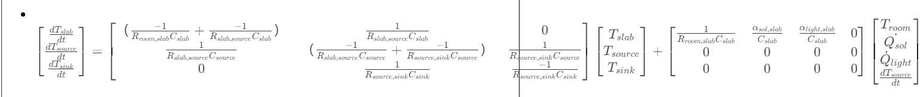

## Performance

# Room Temperature Prediction RC Model

## Performance

# Radiant Slab RC Model 1

Notes:

Thermal insulation as fixed temperature boundary, T_adj =T_sink = 21 C

# Radiant Slab RC Model 2

Notes:

Thermal insulation temperature as one of state variables.

# Performance Comparison

|  |  |
| --- | --- |
| **Radiant Slab RC Model 1** | **Radiant Slab RC Model 2** |
|  |  |

|  |  |
| --- | --- |
| **Radiant Slab RC Model 2**  No lighting consumption data | **Radiant Slab RC Model 2**  With lighting consumption data |
|  |  |